Activity Sheet | Interview An Engineer
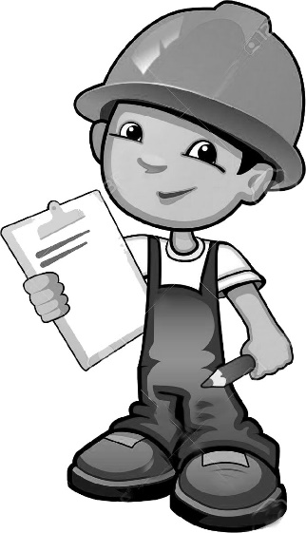
Interviewing an Engineer:
What do the engineer(s) you interview do for a living?

Write down one thing this person does in their job?

What was the most interesting thing they talked about?

Learning about Engineering Careers

What type of engineering did you learn about?

What kind of thing can this engineer make or build?

What does this type of engineer do?

What types of jobs can you have if you are this type of engineer?

What is one interesting fact about this engineering career you learned?

